Bioinformatics Analysis of SOD1 in Amyotrophic Lateral Sclerosis (ALS)

INTRODUCTION:- Amyotrophic Lateral Sclerosis (ALS) is a progressive neurodegenerative disease that affects upper and lower motor neurons, leading to muscle weakness, paralysis, and death, usually due to respiratory failure. Both sporadic and familial forms of ALS exist, with ~20% of familial cases linked to mutations in the **SOD1 (Superoxide Dismutase 1)** gene. SOD1 encodes an antioxidant enzyme responsible for detoxifying reactive oxygen species (ROS). Mutations in SOD1 cause protein misfolding, aggregation, and neuronal toxicity.

OBJECTIVE:- The aim of this project was to analyze ALS-related mutations in the **SOD1 gene** using various bioinformatics tools. Specific objectives include:

* To collect SOD1 mutations from **ClinVar**.T
* o map ALS pathways from **KEGG** and **Reactome**.
* To visualize the 3D structure of SOD1 protein from **PDB**.
* To locate and visualize mutations on the SOD1 protein structure using **PyMOL**.

PROCEDURE:-

1. 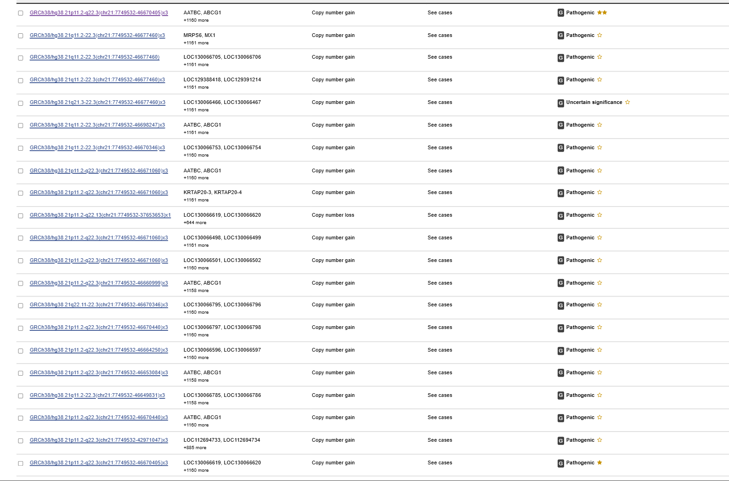ClinVar Analysis- The **ClinVar database** was searched for *SOD1* mutations. Multiple pathogenic and likely pathogenic variants were identified, such as missense mutations (e.g., **A4V, G93A, D90A**). ClinVar results provided mutation positions, type, and clinical significance.

|  |  |  |  |
| --- | --- | --- | --- |
| Variant (Protein Change) | Mutation Type | Clinical Significance | Condition/Phenotype |
| p.Ala4Val (A4V) | Missense | Pathogenic | ALS type 1 |
| p.Gly93Ala (G93A) | Missense | Pathogenic | ALS type 1 |
| p.Asp90Ala (D90A) | Missense | Pathogenic / VUS | ALS type 1 |
| p.Val148Gly (V148G) | Missense | Pathogenic | ALS type 1 |
| p.Leu144Phe (L144F) | Missense | Likely pathogenic | ALS type 1 |
| p.Gly37Arg (G37R) | Missense | Pathogenic | ALS type 1 |
| p.Ile113Thr (I113T) | Missense | Pathogenic | ALS type 1 |
| p.Gly85Ser (G85S) | Missense | Pathogenic | ALS type 1 |
| p.Asn86Ser (N86S) | Missense | Likely pathogenic | ALS type 1 |
| p.Val16Met (V16M) | Missense | Likely benign | ALS type 1 |
| p.Ala15Thr (A15T) | Missense | Uncertain significance | ALS type 1 |
| p.Leu126Val (L126V) | Missense | Benign / Likely benign | ALS type 1 |

1. Pathway Analysis (KEGG)- The pathway highlights key molecular processes such as oxidative stress, mitochondrial dysfunction, protein aggregation, and glutamate excitotoxicity. SOD1 is shown as a critical node connecting oxidative stress to neuronal cell death

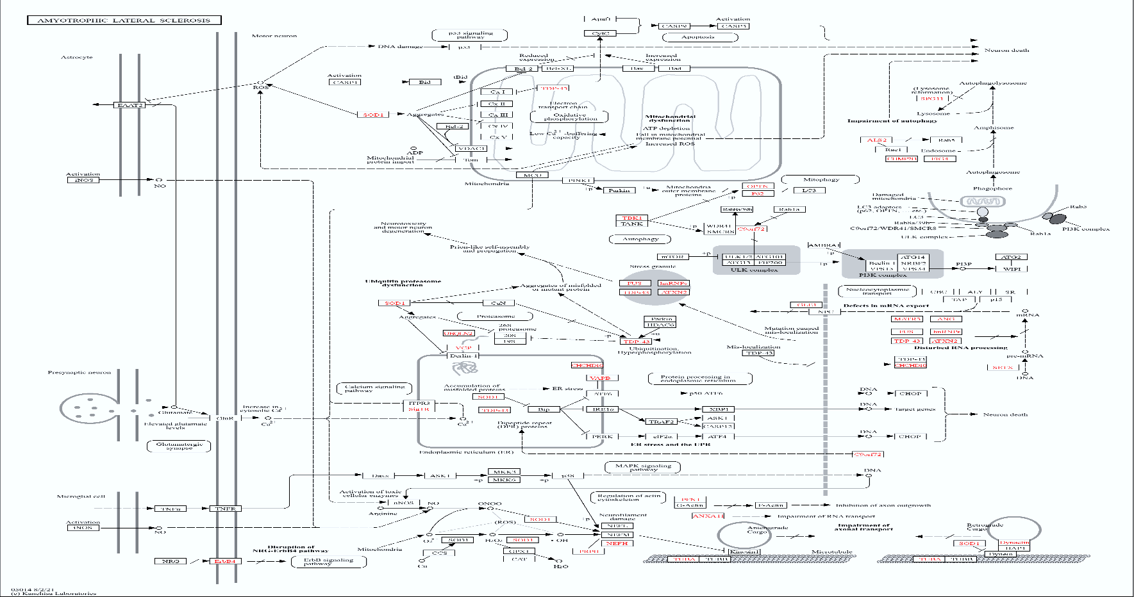

1. Pathway Analysis (REACTOME)- SOD1 was found to participate mainly in **Detoxification of Reactive Oxygen Species**. The pathway map revealed interactions of SOD1 with other antioxidant enzymes (e.g., catalase, peroxiredoxins).

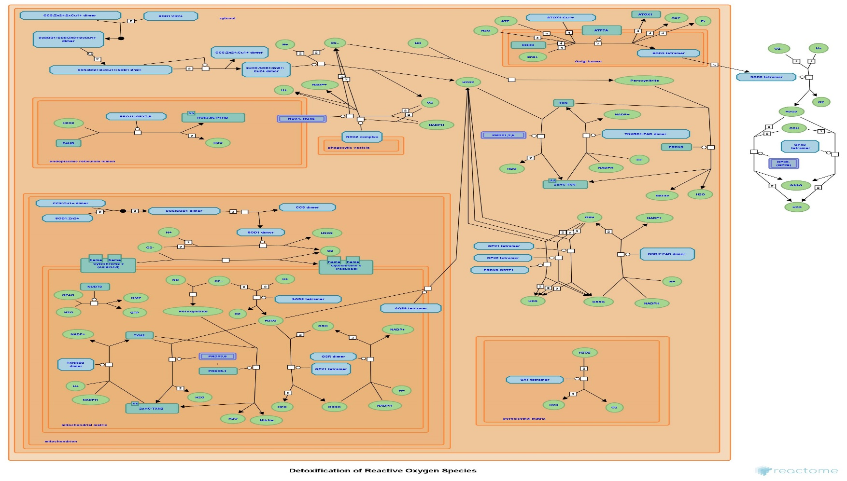

1. Structural Analysis (PDB)- The 3D structure of human SOD1 was retrieved from the **Protein Data Bank (PDB ID: 2RSQ)**.

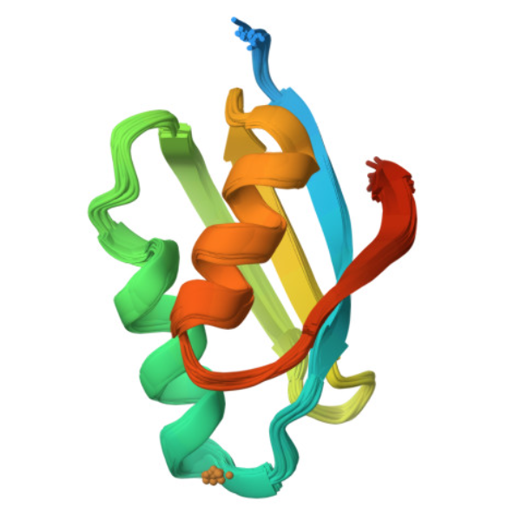

1. Mutation Mapping in PyMOL- The SOD1 structure was visualized using **PyMOL**. Specific ClinVar-reported mutations (e.g., **H46R**) were mapped on the protein. The visualization highlights how mutations are located near the **metal-binding sites (Cu/Zn ions)**, which may disrupt enzymatic activity and stability.

